** SENTIERIGRESSONEY.IT**

**GRESSONEYHIKES.COM**

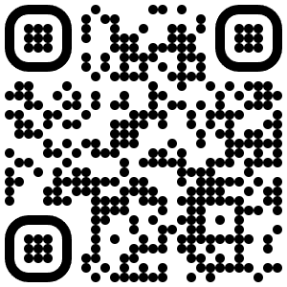

**Italiano:**

**SENTIERIGRESSONEY.

**English:**

**GRESSONEYHIKES.COM**

